This is a simple walkthrough for task 14 of the hackback2 competition on TryHackMe that was hosted in late October 2019

This is the first guide I am writing so do not expect especially high quality.

The room should be available here <https://tryhackme.com/room/hackback2> and should be visible for free

Unfortunately, my team placed 35th as 0x03f3

Step 1. To begin with all we are given is the email address of a certain person and told to figure out various questions about them, the first of which being where they ave gone on holiday

One of the first things you should do upon receiving an email is verify it exists and is active by sending it an email.

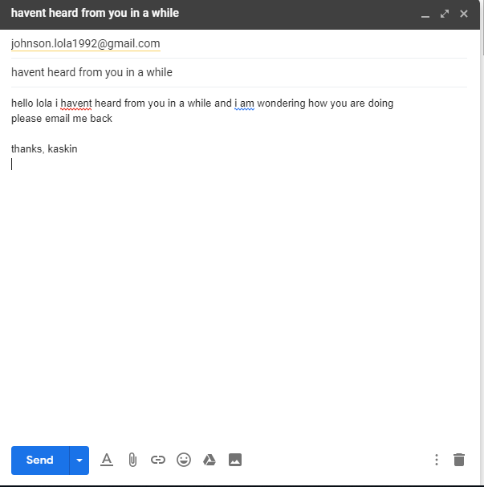

In theory this email doesn’t really need to be anything beyond a blank mail that can be sent but I decided to write something proper for it.

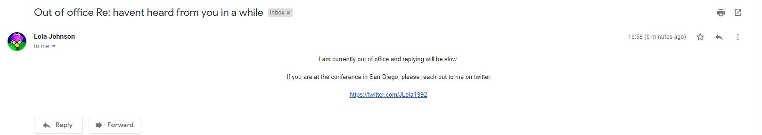

And we have a hit, an auto response mail from them. And conveniently it also mentions they are in san diego at the moment, which is our first answer. It also gives us a twitter that will be useful later.

2.

Well this one is even simpler than it seems, simply look at her email and notice that it ends with a series of numbers that match a year, conveniently she seems to have made a serious security flaw and put an identifier in her own email as this is her year of birth.

3.

For the third task we must look towards the twitter we were given in her email

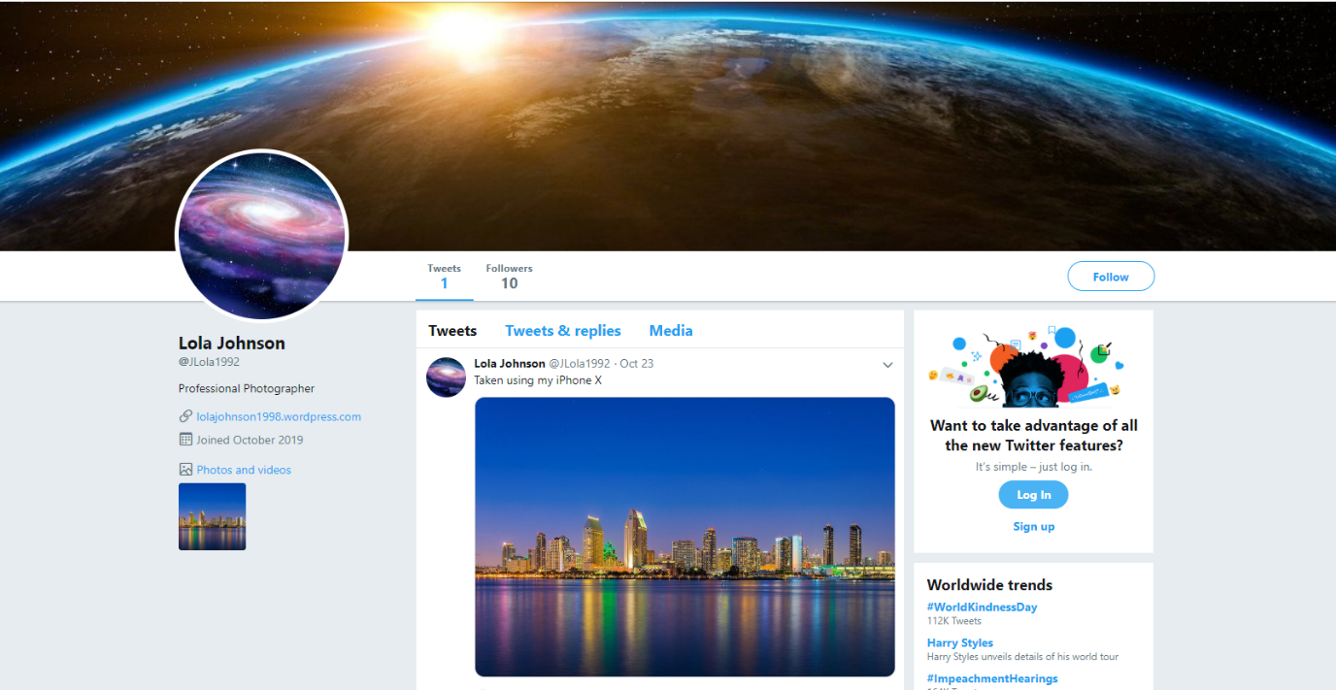

From this simple page we can get so much useful information for example If we look to the left of the page we can see her profession as a professional photographer



4.

question 4 simply asks what phone does she use, which is cleanly visible from her twitter page in her only tweet

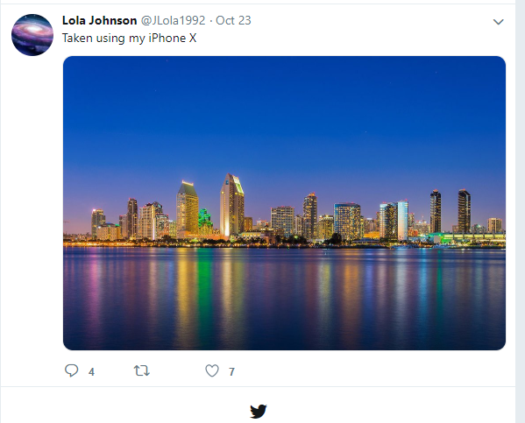

As you can see here she uses an iPhone X

5.

Unfortunately, I never truly finished task 5 and instead resorted to the wonders of educated guesswork based on TryHackMe`s loose security on answer length.

As you can see looking at the answer input we have a single character then a space then a word of 5 characters then a space and a word of 3 characters, using educated guesses based on the layout and type of question we can surmise that it is “x years ago” and then take guesses based on singular digit year eventually reaching the correct answer of “5 years ago”

6. question 6 returns to being simple asking “what is the date of the capture” referring to the photo on the twitter, I in initially went way more complex than needed for this question when instead you simply need to read the date on the tweet to see it was posted on October 23rd.

7. question 7 asks “what is the name of the famous woman she has on her webpage?

As you can see there is no photo of a woman on her twitter however there is a link to a WordPress on her bio



Going there we can quickly see a painting of a lady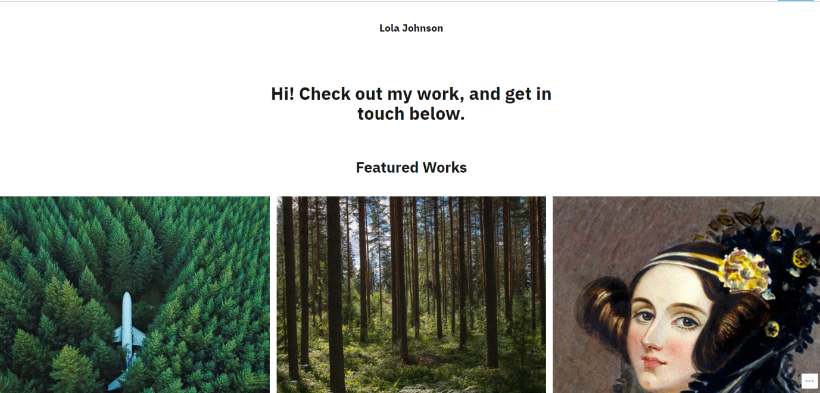

Simply open and save the picture of the lady. Conveniently it even details your next step as the file is titled “reverse_image_search.jpg” as the file says open a reverse image searching tool of choice and run it through there.

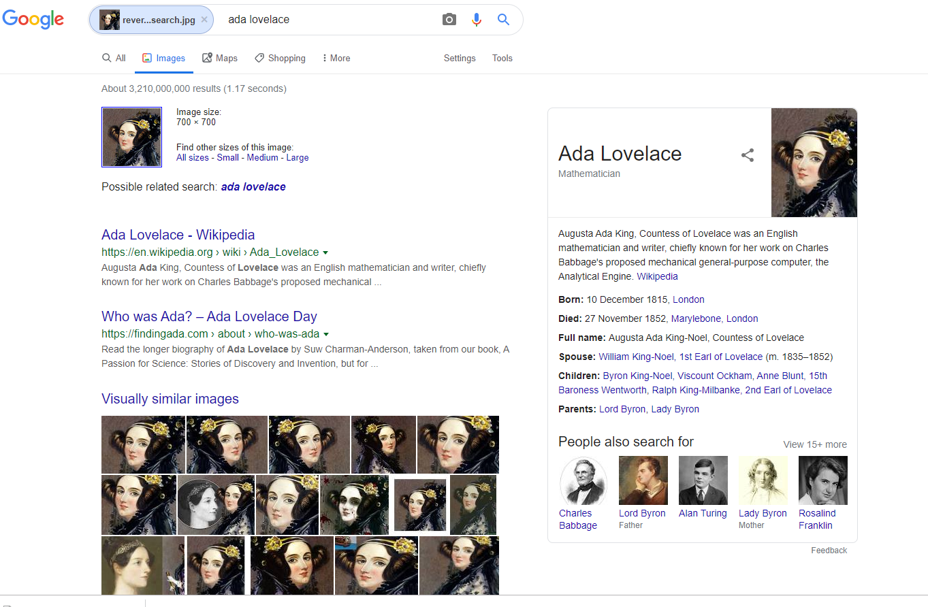

There we go, a reverse image search quickly reveals it to be Ada Lovelace.

And that’s all the flags for task 14 of hackback2!